Integrated Security System (ISS)
For
Sentosa Development Corporation (SDC)

Functional Requirements Document (FRD)
Case Management System
(Version 0.4)

 |  | Name | Designation / Company | Signature
Prepared By | : | Wong Shin Feng | Business Analyst (SJ)
Reviewed By | : | Gan Kian Teck | Application Lead (SJ)
 |  | Valerie Shao | Project Manager (NCS)
Approved By | :

Table of Contents
1. Document Control 7
1.1 Version History 7
1.2 Definitions, Abbreviations, Acronyms 7
2. Overview 10
2.1 Purpose and Scope 10
2.2 CMS Modules 10
2.3 Authentication and Access Control 12
2.3.1 Authentication Method 12
2.4 CMS Dashboard 12
2.4.1 Landing Page and Navigation 12
2.4.2 Summary Metrics 13
2.4.3 Events Master List 14
2.4.4 2D Island Map 14
2.5 Integration with Unified Command System 16
2.5.1 Live Metric Feed to UCS Dashboard 16
2.5.2 Embedded CMS Functions within UCS 16
2.5.3 Navigation from UCS to CMS 17
2.5.4 Incident Creation from UCS 17
2.5.5 External Weather Alert Forwarding 18
2.5.6 Last 10 Actions from CMS to UCS Widget 18
2.5.7 Broadcast Integration with UCS 18
2.5.8 Crisis Recall with UCS 18
3. User Roles and Permissions 19
3.1 System Level Role Definitions 19
3.2 Duty Officer Role Elevation 22
3.3 Role and Status Action Matrix 23
3.3.1 Incident Management 23
3.3.2 Task Management 26
3.3.3 e-Diary Management 28
3.4 Record Data Retention 28
3.5 Stakeholder Incident Record Access 28
4. Case Data Model 29
4.1 Entity Structure and Relationships 29
4.2 Case Entity Relationship 30
4.3 Case Creation 31
4.3.1 Case Field Design 31
4.3.2 Case Status Definitions 31
4.3.3 High-Level Case Process Flow 32
5. Incident Management Module 33
5.1 Incident Classification 33
5.1.1 Incident Types 33
5.1.2 Incident Categories 33
5.2 Crisis Incident Level Classification 34
5.3 Incident Field Design 34
5.3.1 General Information 34
5.3.2 Location 36
5.3.3 Incident Log 37
5.3.4 Emergency Services 38
5.3.5 Media Involvement 38
5.3.6 Property and Vehicles 39
5.3.7 Persons Involved 40
5.3.8 Personal Injuries 40
5.3.9 CCTV and Body Worn Camera 41
5.3.10 Attachments 41
5.3.11 Summary and Closure 41
5.4 Incident Lifecycle 42
5.4.1 Incident Status Definitions 43
5.4.2 High-Level Incident Process Flow 45
5.4.3 Incident Ageing Alerts 45
5.4.4 Incident Reporting Sources 46
5.5 Responder Assignment and Response Tracking 47
5.5.1 Incident Assignment and Notification 47
5.5.2 Incident Response Milestone Tracking 47
5.5.3 Incident Logging 48
5.6 Duplicate Incident Detection and Handling 48
5.7 Incident Record Save and Concurrent Editing 49
5.7.1 Save Mechanism 49
5.7.2 Concurrent Editing 49
5.8 Linked Fault Creation 49
5.9 False Alarm Handling 50
5.10 Incident Closure and Reopening 50
5.11 Broadcasting Triggers 50
5.11.1 Closure Broadcast 50
5.11.2 End-of-Day Interim Broadcast 50
6. Fault Reporting Module 51
6.1 Fault Entry Points 51
6.2 CMMS Ticket Creation 51
6.2.1 Requirements 51
6.2.2 Fault Field Design 52
6.2.3 High-Level CMMS Ticket Process Flow 52
6.3 Fault Status and Information Retrieval 53
6.3.1 Fault Case Status 53
6.4 Non-IFM Fault Handling 53
6.5 Case Linkage and Closure 53
7. Task Management Module 55
7.1 Task Creation 55
7.1.1 Requirements 55
7.1.2 Task Field Design 55
7.2 Task Assignment and Notification 56
7.3 Task Process 57
7.3.1 Requirements 57
7.3.2 Task Statuses 57
7.3.3 High-Level Task Process Flow 58
8. Events Master List Module 59
8.1 Events Creation 59
8.1.1 Requirements 59
8.1.2 Events Field Design 59
8.2 Event Location 60
8.3 Events Schedule File Upload 60
8.4 Event Calendar and List View 60
9. e-Diary Module 61
9.1 E-Diary Creation 61
9.1.1 Requirements 61
9.1.2 e-Diary Field Design 61
9.1.3 Create or Link Records from e-Diary 62
The e-Diary entry shall remain unchanged as the source journal record after an Incident, Task or Event is created or linked 62
9.2 Retrieval and Filtering 62
9.3 UCS Integration 63
10. Broadcast and Notification Framework 64
10.1 Broadcast Types 64
10.2 Delivery Channels 64
10.3 Recipient Group 65
10.4 Broadcast Templates 65
10.5 System Notifications 65
10.6 Broadcast Matrix 67
10.7 End-of-Day Interim Broadcast 67
10.8 SDC Communications Team Notification 67
10.9 Broadcast Record and Export 67
11. Crisis Management and Emergency Recall 68
11.1 Crisis Level Classification and Routing 68
11.2 Crisis Recall 68
11.3 Delivery Channels 69
11.4 SMS Recall Workflow 69
11.5 Recall Groups 69
12. Reporting and Data Export 70
12.1 Operational Statistics Module 70
12.2 Incident Report Export 70
12.3 Case Summary Export 71
12.4 Data Export for Analytics 71
13. System Configuration and Administration 72
13.1 User and Role Management 72
13.2 System Reference Data Configuration 72
13.3 Broadcast Configuration 73
13.4 Recall Configuration 74
13.5 Audit Log 74
14. Non-Functional Requirements 76
14.1 Availability 76
14.2 Performance 76
14.3 Concurrent Users 76
14.4 Security 76
14.5 Session Management 76
14.6 Audit and Compliance 76
14.7 Data Retentional and Archival 76
15. Open Items 77
15.1 UCS 77
15.2 Incident 77
15.3 Broadcast 77
15.4 Central Rostering Module 77
16. Appendix 78

Document Control

Version History
Version | Date | Description
0.1 | 18 May 2026 | Initial Draft
0.2 | 5 June 2026 | Revised draft updating Case and sub-records details
0.21 | 9 June 2026 | Updates to sub-record role/status/action matrix in Section 3.3
0.3 | 15 June 2026 | Updates to Events, Broadcast, Alerts, Role Permissions
0.4 | 19 June 2026 | Updates to Current Ops Admin role, minor amendments to Task Closure,

Definitions, Abbreviations, Acronyms
Term | Definition
2FA | Two-Factor Authentication
AD | Active Directory
BWC | Body Worn Camera
CMS | Case Management System
CMMS | Computerised Maintenance Management System
DM | Duty Manager
DO | Duty Officer
FM | Facilities Management
FRD | Functional Requirements Document
HOTO | Handover and Takeover
IFM | Integrated Facilities Management
IIOC | Island Integrated Operations Centre
IOH | Integrated Operations Hub; used operationally to refer to the IIOC facility and its staff
LO | Liaison Officer
MOS | Method of Statement
NOP | No Objection Permit
NCS | NCS Pte Ltd
OR | Operational Resilience
PTZ | Pan-Tilt-Zoom
RA | Risk Assessment
RBAC | Role-Based Access Control
SCDF | Singapore Civil Defence Force
SCOG | Sentosa Crisis Operations Group
SCMG | Sentosa Crisis Management Group
SDC | Sentosa Development Corporation
SJ | Surbana Jurong
SPF | Singapore Police Force
SSO | Single Sign-On
UCS | Unified Command System
VA | Video Analytics
VMS | Video Management System
WOG | Whole-of-Government

Overview

Purpose and Scope
This document specifies the functional requirements for the Case Management System (CMS) component of the SDC Island Integrated Operations Centre platform, covering
- Incident Management
- Fault Reporting
- Task Management
- No-Objection Permit
- Events Master List
- E-Diary
- Distribution Group Management
- Broadcast and Notification
- CMS Dashboard
- System Configuration and Administration

CMS Modules

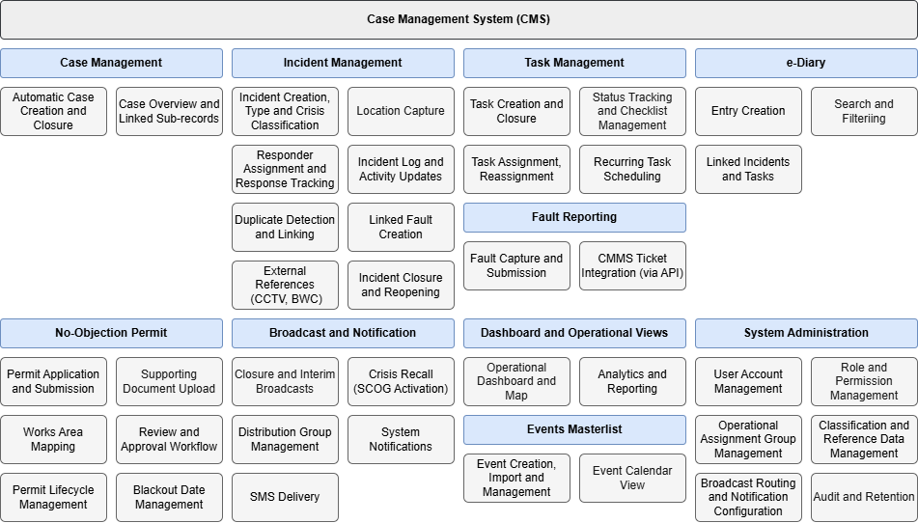
The CMS is a web browser-based platform. All modules are subject to role-based access control; the specific modules, tabs, and functions visible to a given user upon login are determined by their assigned role. The following modules are covered in this document.
Module | Description
Incident Management | Creation, assignment, tracking, and closure of incident records from all reporting sources across the island
Fault Reporting | Creation, automatic triage, routing, and closure of fault records, with rule-based assignment to the IFM contractor and CMMS ticket creation via API where required  Creation, tracking and closure of fault records. Creation of CMMS tickets via API.
Task Management | Creation, assignment and tracking of operational tasks directed to Responders or SDC staff with CMS accounts within a Case  Examples: welfare check, escort, item collection, access arrangements
No-Objection Permit | Permit application, document submission, works-area mapping, review and approval, permit lifecycle management
Events Master List | Creation, import and management of events, including list and calendar views
e-Diary | Creation and retrieval of operational diary entries that cannot be amended or deleted after submission, with support for creating or linking Incidents, Tasks and events
Distribution Group Management | Creation and maintenance of recipient groups used for broadcasts and notifications
Broadcast and Notification | Structured framework for disseminating incident information to defined distribution groups.
Crisis Recall | Recall notification function for selected group of SDC stakeholders governed by the crisis-level classification governing escalation and recall
CMS Dashboard | Consolidated operational and calendar event view of active cases, incidents, faults, and tasks, with a filterable 2D map of island-wide activity
Central Rostering | Proposed module for managing duty rosters and surfacing assigned response team, Duty Manager and other on-duty personnel in CMS and UCS operational views
System Configuration | Administration of user accounts, role assignments, classification taxonomies, location hierarchy, routing matrices, distribution groups, and audit settings

Authentication and Access Control

Authentication Method
SDC users shall authenticate through Whole-of Government Single Sign-ON (WOG SSO). WOG SSO authentication alone shall not grant access to the CMS. The CMS shall verify that the authenticated user has an active, authorised CMS account and an assigned system role. Users who do not meet these conditions shall be denied access and directed to contact the System Administrator.
Non-SDC users shall authentication using a CMS username and password, with 2-factor authentication.

CMS Dashboard
The CMS Dashboard shall provide a consolidated operational view for Controllers, Duty Officers, and Duty Managers.
It is distinct from the UCS Dashboard in scope and purpose: the UCS Dashboard presents live-state summary counts and high-level situational awareness, while the CMS Dashboard provides access to both current and historical records with line-item detail views.

Landing Page and Navigation
Upon successful authentication, users are presented with the CMS landing page. Navigation items visible to a given user are filtered by their assigned role.
Navigation Item | Description
Dashboard | Consolidated operational view of active cases, incidents, faults, tasks, events, no-objection permits, and 2D island map
Case Management | Case log list view and case detail view, with access to linked incidents, faults, tasks and e-diary entries
Incident Management | Incident log list view, incident creation and management, and incident detail view
Fault Reporting | Fault log list view, fault creation and management, and fault detail view
Task Management | Task log list view, task creation and assignment, and task default view
Events Master List | Events list and calendar view, event creation and management, and event-case linking
No-Objection Permit | NOP application log, permit submission, review and approval workflow, and permit lifecycle management
Broadcast and Notification | Broadcast log, crisis broadcast composition and dispatch, and distribution group management
Operational Statistics | Real-time operational analytics and data export of cases, incidents, faults, tasks, events and no-objection permits volume trends. Includes breakdown by status, type, location, processing time metrics, and more.
System Configuration | Administrator-only module for account management and system settings

Summary Metrics
The Dashboard shall display the following operational counters, each filterable by a date and time range selected by the user.
Metric | Description
Active Cases | Count of case records currently in Active status
Incidents Reported | Total count of incident records within the selected period
Unclosed Incidents | Count of incident records not in Closed status
Faults Reported | Total count of fault records within the selected period
Unclosed Faults | Count of fault records not in Closed status
Active Tasks | Count of task records currently in an active status
Overdue Tasks | Count of task records that have passed their due date and are not in Closed status
Events Today | Count of events from the Events Master List that are ongoing or scheduled on the current day
Active NOPs | Count of NOP permits with Approved and Active Status on the current day

Events Master List
The CMS Dashboard shall surface upcoming and active Events from the Events Master List through the Events Today metric, Events map layer, and navigation to the Events Master List module. Event creation, import, location validation and calendar management are defined in the Events Master List Module section.

2D Island Map
The CMS Dashboard shall include an embedded 2D map of Sentosa Island leveraging on OneMap and its available API. The map will provide a consolidated spatial view of active operational activity across the island and is accessible to all users with Dashboard access.
Map Layer | Description
Incidents | Drop-pins for active incident records, derived from the text-entered location data on each incident log. Coordinates are resolved from the entered address, road name, building, or postal code via the OneMap geocoding API  For incidents at locations without a standard address (e.g. beach areas, open outdoor spaces), coordinates are taken from the manually placed pin drop on the incident record.
Faults | Drop-pins for active fault records, resolved by geocoding
Active Works | Boundary overlays for approved and active NOP works areas. Works boundaries drawn by NOP applicants during their application are automatically displayed on this map upon permit approval, providing Controllers with a live spatial overview of all ongoing permitted works on the island
Events | Boundary overlays for upcoming or ongoing events from the Events Master List, based on the Event Location and Event area mapped within the selected location hierarchy
- For locations with defined physical boundaries, such as named buildings and venues, the system shall associate a text-entered location with the corresponding pinned coordinate.
- For road-based locations, which cannot be geofenced, coordinate resolution relies on the geocoding result returned by OneMap for the entered road name or common name.
- Island events at fixed venue sites, such as pavilions, event grounds, and beaches, shall be represented on the map as drop-pin icons.

Geographical Coverage
The map shall support plotting of records across Sentosa Island, and all named off-island SDC operational locations, including:
- Mount Faber Leisure Group premises on Mt Faber and Harbourfront Tower
- SDC-operated berths at Harbourfront Bus Interchange
- VivoCity, nearby MRT stations and bus stops, and other transport nodes in the immediate vicinity
- Designated crisis locations
- Road routes to and from Sentosa Gateway, including all road names on these routes

Map Display Behaviour
Behaviour | Description
Pin Clustering | When multiple pins of the same layer are in proximity at the current zoom level, they are aggregated into a numbered cluster marker showing the record count
Zoom to Expand | Clicking a cluster marker zooms the map to the cluster area, expanding it to reveal individual pins
Pin Interaction | Clicking an individual pin surfaces a summary panel showing the record type, ID, and current status, with a link to the full record in the CMS

Integration Dependency and Data Accuracy
- Map functionality is dependent on the availability of the OneMap API, a government geospatial service maintained by SLA. SJ will be responsible for maintaining the API integration code in line with any changes to OneMap API versioning, endpoints, or authentication specifications. The accuracy and completeness of OneMap's underlying geospatial data is outside the development team's remit.
- The spatial accuracy of plotted records is dependent on OneMap geocoding data, which may not reflect recent construction or changes to the built environment. For locations not yet reflected in OneMap, pin placement relies on the coordinate data in the CMS location taxonomy, which is maintained by the System Administrator via the System Configuration module.

Integration with Unified Command System
The CMS and the Unified Command System operate as complementary but functionally distinct platforms.
While the CMS is the system of record for all operational case data, the UCS is the primary command interface, surfacing a real-time operational overview to Controllers and the Duty Officer.

Live Metric Feed to UCS Dashboard
- The CMS shall supply real-time summary counts to the UCS Dashboard, including the number of active cases, open incidents, open faults, active tasks.
- Summary counts shall update in real time as records are created, updated or closed in the CMS.

Embedded CMS Functions within UCS
- CMS functions that are frequently used or operationally time-critical shall be surfaced as embedded panels or inline actions within the UCS, without requiring the user to navigate away from the UCS interface.
- Actions performed through embedded UCS panels shall create, update, or retrieve records directly in the CMS. The UCS does not store or duplicate CMS data.
- The embedded functions shall operate under the same role-based access controls as the full CMS.
- Controllers shall be able to perform create, read and update operations for the following record types directly from within the UCS:
Record Type | Embedded Operations
Incidents | Create, view and update incident records. Assign responders and update incident status  Acknowledge VA triggers to create Incident records.
Tasks | Create, view, update and reassign task records
CMMS Faults | Create and view fault records, view CMMS ticket reference
e-Diary | Create, view, and amend e-Diary entries
No-Objection Permit | Actionable items involving IOH within NOP workflow
Broadcasts | Create, view, and amend draft Broadcasts. Dispatch authorised Broadcasts using CMS Broadcast templates, recipient groups and delivery-status records
Crisis Recall | View, initiate and confirm Crisis Recall for configured recall groups, including recall dispatch and acknowledgement status where supported by the approved messaging service
Last 10 Actions List | Displays the latest 10 operational actions performed by Controllers in the CMS.
- Embedded operations shall be fully completable from within UCS, such as form input, validation and save shall be performable without the Controller navigating away to the CMS.
- The embedded integration shall function as a working form and data interface, not a link or redirect to the CMS. Implementation method (inline panel, pop-up form, embedded component) is subject to technical design.

Navigation from UCS to CMS
The UCS and CMS are complementary interfaces. CMS functions that are frequently used or operationally time-critical are surfaces as embedded panels or inline actions within the UCS. All remaining CMS functions are accessible from the UCS via direct navigation.
- Where a function is not available as an embedded UCS action, selecting a live metric, summary item, or record reference in the UCS shall direct the user to the corresponding CMS module page.
- Line-item detail, full record editing, case management, and reporting functions are handled within the CMS and are not replicated in the UCS.
- The presentation of CMS data within the UCS, including widget layout, record list columns, display depth and filtering options will be defined in the UCS functional requirements document. A UCS record widget may surface a live list of active records with key fields, such as record ID, status, type and created at, alongside inline quick actions, for embedded operations.

Incident Creation from UCS
- A Controller shall be able to initiate a new Incident record directly from the UCS without navigating to the CMS.
- Incident creation from the UCS shall be available as an inline action, for example in response to a Video Analytics alert, a system-generated prompt, or a patrol report received in the UCS.
- The Incident record shall be created and stored in the CMS. The UCS surfaces the creation interface only; it does not own the record.
- Where a Video Analytics alert or system prompt is used as the trigger, the relevant alert reference shall be pre-populated into the Incident record where applicable.
- Upon successful creation, the Controller shall be able to continue monitoring the UCS or navigate directly to the full Incident record in the CMS.

External Weather Alert Forwarding
- Where weather forecast or weather alert information is surfaces on the UCS, authorised users may initiate an advisory broadcast from the relevant alert
- The advisory broadcast uses configured CMS broadcast templates, recipient groups and delivery channels.

Last 10 Actions from CMS to UCS Widget
- The widget shall display the latest 10 operational actions performed by the Controllers in the CMS
- Each entry shall show the Controller, action, affected record, and date and time
- Actions include record creation, assignment, status changes and closure of operational records

Broadcast Integration with UCS
- Broadcast actions surfaced on the UCS use CMS Broadcast records, templates, recipient groups and delivery-status information.
- Authorised users may create, review, amend and dispatch Broadcasts drafts from the UCS.
- Where an Incident has Broadcast draft or dispatched Broadcast, the UCS displays an indicator on the Incident record, of which selecting it would open the related draft or dispatched Broadcast details
- The CMS remains the system of record for Broadcast records and dispatch history.

Crisis Recall with UCS
- The UCS shall surface Crisis Recall functions for authorised users during crisis operations.
- When an Incident classification triggers Crisis Recall, the UCS shall display the queued recall action, applicable Recall Group and message status for user review.
- The Duty Manager shall be able to review and confirm Crisis Recall dispatch from their UCS terminal
- The UCS shall display recall dispatch status where supported by the approved messaging service.

User Roles and Permissions

System Level Role Definitions
The CMS defines the following system-level roles. A user's assigned role determines their permitted actions across all modules and records within the system.
Role | Description | System Access
System Administrator | Super Admin accounts holding maximum administrative rights, responsible for user provisioning, role configuration, taxonomy management, and system-level settings | - Access to all CMS modules and records  - User provisioning and role configuration  - Configure system reference data, classification taxonomies and system settings  - Audit log access
Current Ops Administrator | Designated operational administrator with Duty Manager-equivalent permissions for operational oversight and support. The role does not perform full system administration. | - View and edit CMS modules and operational records  - Audit log access  - Taxonomy management  - No user provisioning, role configuration
Duty Manager | Senior operational authority on shift. Responsible for incident closure endorsement, escalation decisions, and endorsement of NOP applications | - View and manage all operationals records  - Assign and reassign responders and Task assignees  - Review, return and close Incident records  - Review and authorise Broadcasts and Crisis Recalls
Duty Officer | Senior officer on shift, supervising Controllers. Covers Duty Manager responsibilities during periods of absence under role elevation | - View and manage all operational records  - Assign and reassign responders and Task assignees  - Review and return Incident records  - Exercise Duty Manager permissions when authorised to cover the Duty Manager role
Controller | Primary IOH operator. Creates and manages incident and fault records, assigns Responders, routes tasks, and manages cases through to closure submission | - Create, view and update operational records  - Assign Responders and Task assignees  - Prepare and dispatch authorised Broadcasts
Responder | Field personnel assigned by a Controller to respond to an incident or task. Logs field activities and updates response status milestones within assigned records only  Assigning a Responder is optional. A Controller may complete and submit a record without one. | - View assigned Incidents and Tasks only  - Update response milestones and activity logs for assigned records  - Submit task or incident response completion updates
SDC Stakeholder | SDC internal staff with read access to incident records relevant to their department or operational zone | - View-only for CMS Incident records under their purview
Broadcast Recipient | SDC staff or external stakeholders receiving incident broadcast notifications. No case creation or editing capability | - Receive Broadcasts and notifications sent to configured recipient groups  - No CMS records access unless assigned another CMS role
Zone Manager / Contract Manager (Non-IFM) | SDC staff responsible for systems and assets outside of IFM purview | - Read-only access to incident records relevant to their assigned systems or assets
Operational Resilience Analyst | Read access to incident records for post-incident classification, tagging, and trend analysis. Does not create or edit operational records | - Read-only access to operational records  - Incident tagging and classification  - Access to operational statistics  - Bulk data export in CSV format
SDC Term-Contractor (NOP Applicant) | Island operators and term contractors with a regular operational presence on Sentosa Island, including bus operators (Strides, Tower Transit), facilities management contractors (IFM), and other SDC-engaged entities. | - NOP application submission, document upload), and application status tracking
SDC Term-Contractor (NOP Approver) | Island operator and term contractors that require elevated rights in the NOP module to review and approve NOP applications. | - NOP application submission, document upload), and application status tracking  - NOP application reviewing and approval

Duty Officer Role Elevation
The Duty Officer may be elevated to cover Duty Manager responsibilities during the Duty Manager's absence. In the elevated state, the Duty Officer holds identical permissions to the Duty Manager.
Elevation will apply as a long-term role configuration on a named user. In the case where an elevated Duty Manager is unable to close an incident they created in a prior shift, the incident is closed by the next shift’s Duty Manager.

Role and Status Action Matrix

Incident Management
Incident records progress through the following statuses on the table header from left to right:
Role | Live |  | Live (Assigned) | Live (Acknowledged) | Live (On-Site) / Live (Incomplete) | Live (Completed) | Pending Endorsement | Returned | Closed
Controller | - View  - Edit  - Assign Responder  - Mark false alarm (VA)  - Submit for Endorsement (backdated) |  | - View  - Edit  - Assign / Reassign Responders | - View  - Edit  - Assign / Reassign Responders | - View  - Edit  - Assign Responders | - View  - Submit for Review | View | - View  - Edit  - Return to Responder | View
Responder* | - No access until assigned |  | - View  - Acknowledge | - View  - Notify Arrival On-Site | - View  - Edit  - Notify Completion | View | View | - View  - Edit | Cannot View after 12 hours of incident closure*  See Section 5.6.2 Responder Activity Logging (f)
Duty Officer | - Same as Controller |  | - View  - Edit  - Assign / Reassign Responders | - View  - Edit  - Assign / Reassign Responders | - View  - Edit  - Assign /Reassign Responders | - View  - Submit for Review | - View  When elevated to DM  - Return to Controller  - Endorse/Close | - View  - Edit  - Return to Responder | View
Duty Manager | - View  - Edit  - Assign Responder |  | - View  - Edit  - Assign / Reassign Responders | - View  - Edit  - Assign / Reassign Responders | - View  - Edit  - Assign /Reassign Responders | - View | - View  - Edit  - Return to Controller  - Endorse/Close | - View  - Edit  - Return to Responder | View
SDC Stakeholders |  | View-only access to authorised Incident records, including live Incident Log updates
Current Ops Administrator |  | Same as Duty Manager

Task Management
Task records progress through the following statuses: Created, Re-Assigned, Acknowledged, In Progress, Pending, Further Action, and Closed.
Role | Created | Assigned | Acknowledged | In Progress | Pending Further Action | Closed
Controller | - View  - Edit  - Assign Assignee / group  - Drop Task | - View  - Edit  - Assign / Reassign Assignee  - Drop Task | - View  - Edit  - Assign / Reassign  - Drop Task | - View  - Edit  - Assign / Re-assign  - Drop Task | - View  - Edit  - Assign / Re-assign  - Drop Task | - View  - Reopen Task
Assignee* | - No access | - View  - Acknowledge | - View  - Begin Task | - View  - Log activity  - Update checklist  - Mark Complete  - Flag cannot complete | - View | View
Duty Officer | - View  - Edit  - Assign Assignee/ group  - Drop Task | - View  - Edit  - Assign / Reassign Assignee  - Drop Task | - View  - Edit  - Assign / Reassign  - Drop Task | - View  - Edit  - Assign / Re-assign  - Drop Task | - View  - Edit  - Assign / Re-assign  - Drop Task | - View  - Reopen Task
Duty Manager | - View  - Edit  - Assign Assignee / group  - Drop Task | - View  - Edit  - Assign / Reassign Assignee  - Drop Task | - View  - Edit  - Reassign  - Drop Task | - View  - Edit  - Assign / Re-assign  - Drop Task | - View  - Edit  - Assign / Re-assign  - Drop Task | - View  - Reopen Task

e-Diary Management
Role | Create | View | Edit | Delete
System Administrator | Yes | All entries | No | Yes
Current Ops Administrator | Yes | All entries | No | No
Duty Manager | Yes | All entries | No | No
Duty Officer | Yes | All entries | No | No
Controller | Yes | All entries | No | No

Record Data Retention
When a user account is deactivated or removed, their associated records should remain accessible to users with appropriate role permissions, with the original creator's identity preserved on each record.

Stakeholder Incident Record Access
Upon creation of an Incident and confirmation of Incident Type, CMS accounts of SDC stakeholders associated with the relevant incident type will be granted view-only access to the Incident Record for incident visibility and live updates of the incident log.

Case Data Model
The Case is the top-level record in the CMS. All operational activity is anchored to a Case.

Entity Structure and Relationships
For the purpose of the CMS, an operational event is any occurrence requiring official action by a Controller or above, including security incidents, fault reports, directed tasks, and e-Diary log entries.
A Case is created for each operational event, and the sub-record that triggers the Case carries the operational detail. The CMS data model is organised around the Case as a lean operational record container. The Case holds an identifier, a status, and references to its associated sub-records.
- A Case may be created independently of any child record.
- A Case may contain zero or one Incident record.
- A Case may contain zero or more Task records.
- A Case may reference zero or more CMMS Ticket IDs. These identifiers are returned by the IFM CMMS upon ticket creation and stored as reference attributes of the Case. The ticket lifecycle is owned entirely by the IFM CMMS.
- An Incident, Task, or CMMS Ticket reference cannot exist in the CMS without an associated Case.
- Where a Case does not exist at the time of Incident or Task creation, the system shall auto-create a Case before creating the child record.
- e-Diary records are linked to a Case. A Case is auto-created on creation of an e-Diary entry if no existing Case context is present. An e-Diary entry does not trigger a ground response, work order, or broadcast, it is a log record only.
- Events are managed as Events Master List records. They may be created from or linked to e-Diary entries for traceability, but they are not Case sub-records and do not affect status or automated Case closure.

Case Entity Relationship
The following diagram illustrates the relationship between the Case and its linked record types.
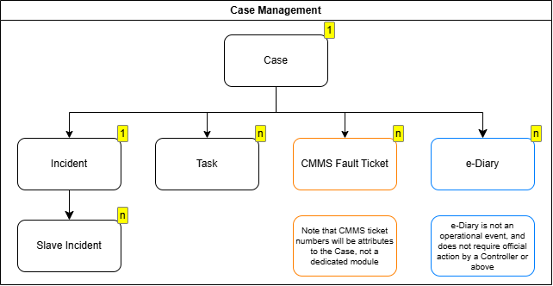
Figure 4-1 - Case Entity Relationship Model
Entity | Cardinality | Description
Case | Parent | The operational record container. One Case is created per operational event
Incident | Zero or one per Case | The formal incident record managed by the Controller. A Case may contain at most one Incident
Linked (Slave) Incident | Zero or many per Incident | Duplicate incident reports linked to a Master Incident.
Task | Zero or many per Case | Operational ground response tasks assigned to Rangers or SDC staff. Multiple Tasks may exist under one Case simultaneously.
CMMS Fault Ticket | Zero or many per Case | Reference identifiers for tickets raised in the IFM contractor's CMMS via API.  Stored as attributes on the Case.  CMMS ticket lifecycle is managed externally.
e-Diary | Zero or many per Case | Occurrence log entries linked to a Case. e-Diary entries do not trigger a ground response, work order or broadcast.

Case Creation
- System shall generate a unique identifier upon creation.
- The Case ID is referenced by all child records (Incident, Tasks, CMMS Tickets, e-Diary) for traceability.

Case Field Design
Field | Type | Mandatory | Notes
Case ID | System | Yes | Auto-generated, format: SEN/CI/YYYYMMDD/NNN
Case Title | Text | No | Auto-populated for VA and system-triggered Cases, otherwise input by Controllers
Status | System | Yes | System-managed
Created By | System | Yes | Auto populated, referencing CMS user record
Created At | System | Yes | Auto populated timestamp
Closed By | System | No | Auto populated on Case closure, referencing CMS user record of Duty Officer/Duty Manager
Closed At | System | No | Auto populated timestamp on Case closure

Case Status Definitions
Status | Description
Pending Triage | Initial status on Case creation. The Controller has not yet determined whether action is required
Active | Action has been determined as required. One or more sub-processes (Incident, Task, CMMS Ticket) are in progress
No Action Required | No operational action is required or taken. Applies to: (a) VA or system-triggered Cases assessed by the Controller as non-actionable; (b) Cases auto-created by new e-Diary entry.  If an e-Diary entry subsequently escalates, the Case transitions to Active on creation of a linked Incident, Task, or CMMS Fault record.
Closed | All linked Incident, Task, and CMMS Ticket records are resolved. The Case is read-only
The Controller may close a Case after a CMMS Ticket has been raised, without waiting for the IFM contractor to resolve the ticket.

High-Level Case Process Flow
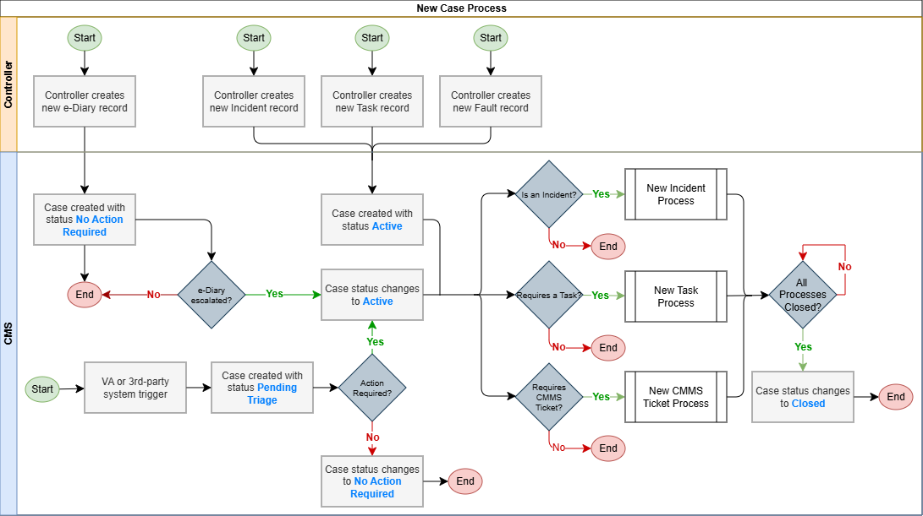
Figure 4-2 - Case Process Workflow

Incident Management Module
The Case is the primary operational record container in the CMS. Every operational activity on the island, whether an incident, a ground response task, or an infrastructure fault requiring contractor action, is anchored to a Case record.

Incident Classification

Incident Types
- Each incident record shall be assigned a Type and a Sub-type from SDC's defined classification taxonomy.
- Both Type and Sub-type fields are mandatory.
- Sub-type values are unique within each Type. An Others option shall be available as a Sub-type of last resort where no defined Sub-type accurately describes the incident.
Note: Finalised Incident Type and Sub-type taxonomy to be confirmed

Incident Categories
Beyond Type and Sub-type, the following operational categories apply to incident records and govern how they are handled within the system. These categories are for-info and not noted in the system.
Category | Description
Standard Incident | An active incident requiring Controller management and, where applicable, a Ranger field response
Proactive Incident | Created by the Controller in response to a notification or advisory where no immediate ground response is required. Common examples include missing person lookouts and lost item notices
Backdated Incident | Created to record an incident that has already occurred and concluded, typically following notification from a state agency after the fact. The record is created, populated with the known details, and closed immediately
Ongoing Incident | An incident that remains open over an extended period while the situation develops and is actively monitored. Common examples include prolonged state emergencies or extended search operations
Informational / Exercise Records | An administrative record created for tracking purposes, covering planned exercises, drills, or coordinated information dissemination. These records do not require a ground response or broadcast

Crisis Incident Level Classification
- Each Incident shall be assigned a Crisis Level at the point of creation or escalation by a Controller
- The Crisis Level determines the broadcast type, distribution group, and escalation behaviour triggered upon or during the incident.
- The Crisis Level is assigned by the Controller at the point of incident creation and may be escalated by the Duty Manager or Duty Officer as the incident develops.
- By default, the Crisis Level is set at Level 4 at incident creation. The Controller is expected to review and update the classification as the situation develops.
- The system shall surface a reminder to the Controllers on-duty 45 minutes from the incident creation, prompting review and confirmation of the Crisis Level. The reminder does not escalate nor amend the level automatically.
Note: Full classification and routing behaviour is defined in further sections on Broadcasts.

Incident Field Design
The incident record is structured into the following sections. Fields marked as mandatory must be completed before the record can be submitted for review.

General Information
Field | Type | Mandatory | Notes
Incident ID | Auto generated | Yes | System generated unique identifier, read-only  Format: SEN/IR/YYYYMMDD/NNNN
Case ID | Auto generated | Yes | System-generated unique identifier. Read-only.  If no existing Case context is present, a new case is auto created, and the Case ID is generated and assigned.  If the Incident is created within an existing Case, the existing Case ID is pre-populated
Linked Fault Record | System Reference | No | Displays linked Fault records. Opens the Fault detail view
Linked e-Diary Entries | System Reference | No | Displays source and linked e-Diary entries. Opens the e-Diary detail view
Incident Title | Text | Yes | Auto generated when incident is triggered by a third-party system, e.g. "VA: Abandoned Object @ Cove". Manually entered by Controller for all other incidents
Date and Time of Incident | Date/Time | Yes | Defaults to current date and time. Backdating is permitted with no restriction
Incident Type | Dropdown | Yes | Selected from SDC's defined taxonomy. Refer to Appendix C
Incident Sub-type | Dropdown | Yes | Values are unique within the selected Incident Type. Refer to Appendix C
Priority | Dropdown | Yes | High, Normal; Default to Normal
Crisis Level | Dropdown | Yes | To be assigned by 1 hour after incident creation. Notification to confirm 45mins after incident elapsed
Reporter's Name | Text | No | Refers to the source of the incident report, not the Controller completing the form
Requested By | Text / Dropdown | No | The party who initiated the report or requested action
Created By | Auto | - | Populated from the authenticated user account. Read-only
Status | System-managed | - | Changes in status are triggered by actions in the incident process. Refer to Section 5.4.1 for Incident status definitions
Assigned To | User | No | Ranger or Responder assigned by the Controller

Location
Field | Type | Mandatory | Notes
Road | Text | No | Road name or nearest road reference
Building | Text | No | Building name where applicable
Level and Space | Text | No | Floor level and specific space within the building
Beside / Near To / At | Text | No | Directional qualifier, e.g. "Lane 2", "near the entrance"
Common Name | Text | No | Free text accepting building names, lamp post numbers, or bus stop numbers
Postal Code | Text | No | Defaults to 000000 for locations without a postal code
Location Tags | Tags | No | Predefined zone and facility tags for filtering and reporting
Mini-map | Map display | - | Displayed after location entry via postal code or address search for address confirmation  Supports manual pin drop for locations without a standard address. Postal Code defaults to 000000 when a pin is placed.

Incident Log
The Incident Log section captures a chronological, row-by-row account of the incident as it unfolds. Each row is timestamped and auto sorted by date and time.
Field | Type | Mandatory | Notes
Event Number | Auto generated | - | Sequentially assigned per row
Date | Date | Yes (per row) | Date of the event entry
Time | Time | Yes (per row) | Time of the event entry
Event Description | Free text | Yes (per row) | Controller's account of the event at that point in time

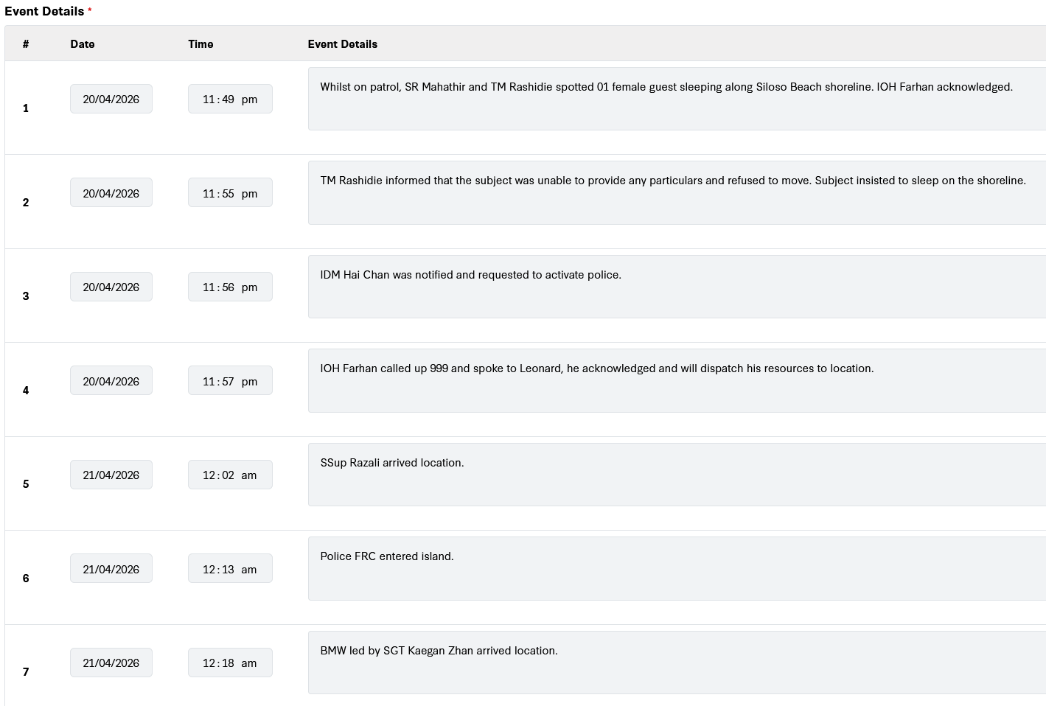
Sample screenshot of Incident Log

Emergency Services

Police
Field | Type | Mandatory | Notes
Police at Scene | Checkbox | No | Indicates police presence at the incident
Officer Name and Rank | Text | No | Name and rank of the attending officer
Police Incident Number | Text | No | Reference number from the police
Classification | Text | No | Police classification of the incident
Responding Unit | Text | No | Unit or station responding

Ambulance and SCDF
Field | Type | Mandatory | Notes
Type | Dropdown | No | Ambulance or SCDF
Officer Name | Text | No
Call Sign | Text | No
Responding Unit | Text | No
Arrival Time | Time | No
Hospital Conveyed To | Text | No | Name of hospital if patient was conveyed

Media Involvement
Field | Type | Mandatory | Notes
Media at Scene | Checkbox | No | Indicates media presence at the incident
Media Name | Text | No | Name of the media organisation or outlet present
SDC Comms Notification | Prompt | — | A prompt or reminder mechanism shall be surfaced when media presence is indicated, to ensure the Controller notifies the SDC Communications team.

Property and Vehicles

Property Damage
Field | Type | Mandatory | Notes
SDC Property Damaged | Checkbox | No | Indicates whether SDC-owned property was damaged in the incident
Description | Text | No | Description of damage where applicable

Vehicles Involved
Field | Type | Mandatory | Notes
SDC Vehicle Involved | Checkbox | No | Indicates whether an SDC-owned vehicle was involved
Vehicle Model | Text | No
Vehicle Number | Text | No
Driver Name | Text | No
Driver Contact Number | Text | No
Driving Licence Number | Text | No
Driver Address | Text | No
Remarks | Text | No

Persons Involved
Field | Type | Mandatory | Notes
Guest or non-Guest | Dropdown | No | Indicates whether the person is a guest of the island or otherwise
Type | Dropdown | No | Guest, Staff, Island Partner or Contractor, Resident, Others
Name | Text | No
Address | Text | No
Age | Number | No
Gender | Dropdown | No
Contact Number | Text | No
Role or Involvement | Text | No | Free text describing the person's role, e.g. victim, witness, bystander
Injury Details | Checkbox | No | Surfaced if the person sustained an injury

Personal Injuries
Field | Type | Mandatory | Notes
Clinic or Hospital Attended | Text | No
MSIG Form Issued, | Checkbox + Text | No | Indicates whether an MSIG form was issued. If yes, Serial Number field is surfaced
Under-16 Indicator | Checkbox | No | If the injured person is aged 16 or below, a parental or guardian details sub-form is surfaced
Parent or Guardian Name | Text | No | Surfaced conditionally when under-16 indicator is selected
Parent or Guardian Contact | Text | No | Surfaced conditionally when under-16 indicator is selected

CCTV and Body Worn Camera
This section records references to CCTV footage and Body Worn Camera footage relevant to the incident. Multiple entries are supported for incidents spanning several locations or involving multiple officers.
Footage retrieval is performed via the VMS and is not accessible directly from within the CMS.
Field | Type | Mandatory | Notes
Camera Number | Text | No | Multiple entries supported
VMS Timestamp | Time | No
VMS Footage Bookmark | Text | No | Reference bookmark within the VMS footage
BWC Number | Text | No | Body Worn Camera identifier
BWC Timestamp | Time | No

Attachments
Field | Type | Mandatory | Notes
Attachments | File upload | No | Accepted formats: photo, video, and document files. Police reports shall not be attached in this section

Summary and Closure
Field | Type | Mandatory | Notes
Summary | Rich text | No | Free-text summary field, relocated below the Personal Injuries section. Renamed from Remarks in the previous system
Completion Remarks | Text | Conditional | Free text remarks field for the Duty Manager when reviewing an incident submitted for closure. Used to record approval notes or, where the record is being returned, to specify the revision required by the Controller.  Mandatory when the DM selects Return, optional when approving.
Closed By | Auto | - | Populated from the authenticated user account upon closure. Read-only
Closed At | Auto timestamp | - | System timestamp recorded at the point of closure. Read-only
Closure Broadcast Status | System reference | No | Displays whether a closure broadcast is not required, pending, or dispatched. Where dispatched, displays the latest Broadcast ID and dispatch status

Incident Lifecycle
- An Incident record shall be created either manually by a Controller or automatically triggered from a third-party source or the UCS.
- Where a Case does not already exist, Case creation is triggered automatically before the Incident record is initialised.
- The Controller may assign one or more Responders to the Incident. Assignment is optional; an Incident may be managed without a Responder assigned.
- The Incident progresses through defined statuses reflecting its operational state.
- Upon closure, the system shall automatically record the identity of the closing user and the closure timestamp.
- Closed Incident records are read-only. A System Administrator must revert the status to an active state before any edits can be made.

Incident Status Definitions
Status | Description | Permitted Actions
Live | Incident created and active. No Responder assigned. | Controller  - Edit  - Assign Responder  - Mark false alarm
Live (Assigned) | Responder has been assigned by Controller, awaiting Responder acknowledgement | Controller  - Edit  - Assign/Reassign Responder  Responder  - Acknowledge assignment
Live (Acknowledged) | Assigned Responder has acknowledged. | Controller:  - Edit  - Reassign  - Update to On-site  - Log activity  Responder:  - Update to On-site  - Log incident
Live (On-Site) | Responder has confirmed arrival at the incident location and updated the Incident record, including the incident log and relevant on-site information | Controller:  - Edit  - Log incident  Responder:  - Log incident
Live (Incomplete) | Controller has reviewed all required Responder updates and determined that further information or amendments are required | Controller:  - Edit  - Return to Responder  Responder:  - Update incident  - Submit updates for Controller review
Live (Completed) | Controller has reviewed all required Responder updates and confirmed that the Incident record is complete | Controller:  - View only  - Submit for closure
Pending Endorsement | Submitted for Duty Manager approval to close incident | Duty Manager:  - Approve closure or return to Controller  Controller:  - View only
Returned | Duty Manager has retuned the incident to the Controller for amendment, with Completion Remarks specifying the required changes. | Controller:  - Edit  - Return to Responder
Closed | Approved for closure. Record is read-only. | System Administrator:  - Revert status  All roles:  - Read only

High-Level Incident Process Flow
The following diagram illustrates the end-to-end incident lifecycle from creation through to closure.
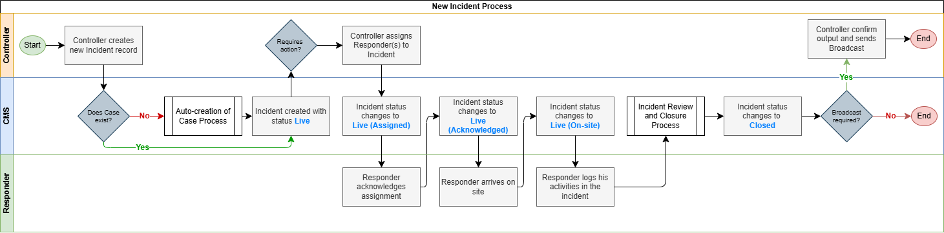
Figure 5-1 - Incident Creation and Assignment Workflow
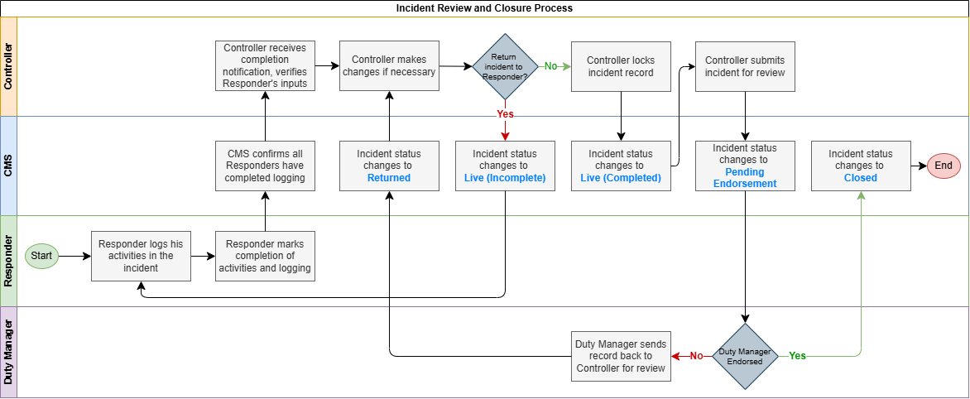
Figure 5-2 - Incident Review Process

Incident Ageing Alerts
Incident Ageing Alerts support Duty Manager and Controller review of long-running active Incidents.
- Where an Incident remains in an active status for 12 consecutive days from the date of creation, an advance notification is generated to the assigned Controller and Duty Manager, prompting review of the Incident status.
- Where an Incident remains in an active status for 14 consecutive days from the date of creation, a further notification is generated to the assigned Controller and Duty Manager, requiring action toward closure.
- A daily Incident Ageing summary is generated for Duty Manager review 30 minutes after shift start.
- The summary lists active Incidents that have reached the 12-day or 14-day ageing threshold, including Incident ID, Incident Type, assigned Controller, current status and days open.

Incident Reporting Sources
- All Incident records, regardless of source, area created manually by a Controller within the CMS or from within the UCS.
- The originating source shall be recorded as a field on the Incident record for audit and reporting purposes.
- The VA system does not create incident records autonomously. Controllers review and confirm each alert before a record is created.
- The below table shows some examples of sources of incidents, but not limited to the following:
Source | Channel | Logging Method
Guest or Member of Public | 1800 duty phone. Controller receives the call directly | Controller creates the incident record during or after the call
Guest or Member of Public | Email to SDC's contact address | Controller creates the incident record upon reviewing the email
Staff or First Responder | Duty phone, direct call, or WhatsApp | Controller creates the incident record from details communicated by the staff member
Video Analytics System | VA alert surfaced on the UCS. Controller reviews the alert and determines whether it is genuine | Controller creates the incident record from within the UCS if the alert is confirmed genuine.  Where a Controller acknowledges the alert but is unable to complete the record, the incomplete item remains visible in the UCS open case list for pickup by another Controller
Fire Alarm System | Fire alarm alert triggered at the IIOC | Controller creates the incident record upon receiving the alert
Carpark Intercom | Two-way intercom between a driver at the carpark gantry and the IIOC | Controller creates an incident record only where the interaction requires follow-up action, such as a barrier fault. Routine interactions that require no follow-up are not logged
State Agency (SCDF, SPF, MPA) | State agency contacts the IIOC duty phone to notify of an incident | Controller creates the incident record from the details communicated. Where the state agency notifies SDC of an incident that has already concluded, the Controller creates a backdated incident record and closes it immediately. No system integration exists between the CMS and any state agency

Responder Assignment and Response Tracking

Incident Assignment and Notification
- A Controller may assign one or more Rangers or SDC staff to an Incident as Responders.
- Assignment may occur at creation or at any point while the Incident is in a Live status.
- The system shall notify the assigned Responder upon assignment via the configured notification channel.
- Multiple Responders may be assigned to a single Incident.
- A Responder may be reassigned by a Controller while the Incident is active.

Incident Response Milestone Tracking
The CMS records and timestamps each milestone in the incident response lifecycle, supporting real-time operational monitoring, post-incident review and response time benchmarking.
Response milestone tracking applies to Informational and/or Exercise Records only where a Responder is assigned. Informational records may be created, managed and closed without Responder assignment when the record is for information tracking purposes only.
The system shall record the following response milestones against each assigned incident:
Milestone | Status Transition | Recorded By | Status Update
Dispatch | Incident assigned by Controller to Responder | Controller
Acknowledgement | Responder confirms receipt of assignment | Responder or Controller. | Status changes to Live (Acknowledged)
Arrival on Site | Responder confirms arrival at the incident location | Responder or Controller. | Status changes to Live (On-Site)
Activity Updates | Responder logs actions taken at scene | Responder or Controller. Free text entries within the Responder activity section
Completion | Responder notifies completion of ground activities and logging of actions taken | Responder or Controller. | Status changes to Live (Completed)

Incident Logging
The Incident Log section is a dedicated segment within the incident record. section. It is accessible to the assigned Responder and Controllers and is used to log the actions taken during the ground response.
The Incident Record refers to the whole Incident within the Case, while the Incident Log refers to the chronological, row-by-row account of the incident as it unfolds.
- Responders and Controllers shall be able to log incident updates
- Selection of incident type/sub-type should support typing for free-text, but also support auto-complete from a predefined type/sub-type list to guide Responders to quick-fill
- Incident log entries are timestamped and attributed to the logging user or by System.
- Incident logs are editable even after submission, until the Controller submits the Incident to the Duty Manager for closure review.
- Incident log entries are visible to Controllers and Duty Managers in the Incident record view.
- Upon closure, the assigned Responder(s) retain read-only access to the incident record for 12 hours from the closure timestamp. After 12 hours, the incident record will no longer be visible to the Responder.

Duplicate Incident Detection and Handling
Multiple reports of the same incident may be received concurrently from different sources, e.g. several guests calling the 1800 hotline about the same event within a short period.
- The system shall flag the Controller when a potential duplicate incident is detected during manual creation, based on matching criteria including date, time, incident type, and sub-type.
- The Controller retains the option to proceed with creating a new record, override the duplicate flag, or link the new record to an existing incident
- Where a record is confirmed as a duplicate, it shall be marked as a linked duplicate and not treated as an independent active Incident
- Linked duplicates shall not generate independent response workflows or separate broadcast triggers
- Closing the Master Incident shall automatically close all linked duplicate records.

Incident Record Save and Concurrent Editing

Save Mechanism
- The system shall auto-save all form input at regular intervals while an incident record is being edited, to minimise data loss in the event of session timeout or interruption.
- A manual save action shall also be available to the user at any point during editing.
- A record in an unsaved state shall display a visible indicator to the user.
- Unsaved changes shall not be discarded without user confirmation.
- The auto-save interval shall be configurable by the System Administrator.

Concurrent Editing
- Where two Controllers access and edit the same incident record simultaneously, the system shall manage the conflict to prevent one Controller's saved input from silently overwriting the others without notification.
Scenario | Required Behaviour
Second user opens a record already being edited | The system shall notify the second user that the record is currently being edited by another user
Both users save changes to the same record | The system shall not silently discard either user's input. A conflict resolution mechanism shall be applied to surface the discrepancy and prompt resolution

Linked Fault Creation
Where an incident reveals an underlying infrastructure defect, a Fault Report may be created directly from the incident record.
- A Controller may raise a fault record from within an active Incident where physical defect is identified as part of or resulting from the incident.
- Fault creation from an Incident record shall initiate the CMMS ticket creation workflow
- The fault record shall be linked to the originating incident and shall be visible from both the incident and fault detail views.
- The incident and fault are managed independently once created. Either may be closed before the other.
- Incident may be closed after the immediate situation is resolved while the fault record remains open as the infrastructure repair and investigation continue.

False Alarm Handling
- Where an incoming report or VA alert is reviewed by the Controller and determined to require no action, the Controller may log the record and mark it as a false alarm.
- A false alarm record, including the identity of the closing user, shall be retained in the system as a closed record for audit and reporting purposes.

Incident Closure and Reopening
- Incident closure requires Duty Manager or designated in-charge approval, except for false alarm closures
- A Controller shall submit an Incident for closure by transitioning it to Pending Endorsement status
- The Duty Manager shall review the record and either approve closure or return it with comments.
- Upon approval, the Incident status changes to Closed and the Case closure process is triggered if all linked records are resolve.
- To reopen a closed incident, a System Administrator must revert the status from Closed to the appropriate active status.
- Once the Incident status is updated to Closed, the system shall generate a closure broadcast prompt for the Controller, where a closure broadcast is required under the configured broadcast rules.

Broadcasting Triggers
Broadcast specifications including delivery channels, templates, recipient group management, crisis level classification, and the routing matrix are defined in Section 10: Broadcast and Notification Framework.

Closure Broadcast
- The system shall automatically trigger a closure broadcast notification to the Controller when the Duty Manager or designated In-charge approves incident closure.
- The Controller shall review the closure broadcast content, confirm the recipients, and dispatch the broadcast. One closure broadcast shall be issued per incident where closure broadcast is required.
- The Incident record shall display the closure broadcast status and linked Broadcast ID once a closure broadcast has been dispatched

End-of-Day Interim Broadcast
- For incidents that remain active at the end of the operational day, the system shall flag open incidents for inclusion in the end-of-day batch review queue.
- The Duty Manager reviews and approves dispatch for each flagged incident

Fault Reporting Module
The Fault Reporting module is the single point of entry within the CMS for logging fault records and initiating ticket creation in the IFM CMMS.
- Triage, routing and severity classification of faults are handled by the IFM on the CMMS. The CMS does not replicate or manage any part of the fault or work order lifecycle
- The CMS role includes:
- Data Capture at point of fault submission
- Ticket creation in the CMMS
- Storage of the returned CMMS Fault ID in the Case record
- Subsequent retrieval of fault information from the CMMS using that stored identifier

Fault Entry Points
Fault records may be created within the CMS through the following entry points:
Entry Point | Description
From an active Incident record | A Controller raises a fault from within an active Incident where a physical defect is identified as part of or resulting from the Incident.
Standalone Case | A Controller creates a fault as a standalone Case where a fault is reported directly, independent of any Incident.
SDC Staff Application | SDC staff submit a fault report through the Staff Application, directly into the CMMS. The CMS may receive the Fault reference and status updates pushed by the CMMS.
.

CMMS Ticket Creation

Requirements
- Upon fault submission, the system shall check whether an existing Case is associated with the request.
- Where no Case exists, the system shall auto-create a Case before proceeding with ticket creation
- The CMMS returns a Ticket ID upon successful creation, which the system stores as an attribute on the Case record.
- The CMMS subsequently manages and updates the ticket status independently of the CMS.

Fault Field Design
The fields captured by the CMS at the point of fault creation, and transmitted to the CMMS API, shall be defined in alignment with the CMMS API specifications.
Field | Type | Mandatory | Notes
Field ID | System | Yes | Auto-generated, format SEN/FR/YYYYMMDD/NNN
Case ID | System | Yes | Auto populated, refencing parent Case
Fault Type | Dropdown | Yes | Populated from configurable taxonomy
Fault Sub-type | Dropdown | Yes | Sub-options based on selected Fault Type, from configurable taxonomy
Location | Lookup / Text / Pin Drop | Yes | Follows incident location hierarchy:  Road | Building | Level + Space
Description | Text | Yes | Free text description of fault observed
Attachments | File Upload | No | Supporting photos/documents
Created By | System | Yes | Auto populated, referencing CMS/SDC staff app user record
Created At | System | Yes | Auto populated timestamp
Submitted At | System | No | Auto populated timestamp on submission to CMMS
Fault Ticket ID | System | No | Reference Ticket ID returned by CMMS API on successful submission
Closed By | System | No | Auto populated on Case closure, referencing CMS user record of Duty Officer/Duty Manager
Closed At | System | No | Auto populated timestamp on Case closure

High-Level CMMS Ticket Process Flow
The process flow for CMMS ticket creation is illustrated in the diagram below.
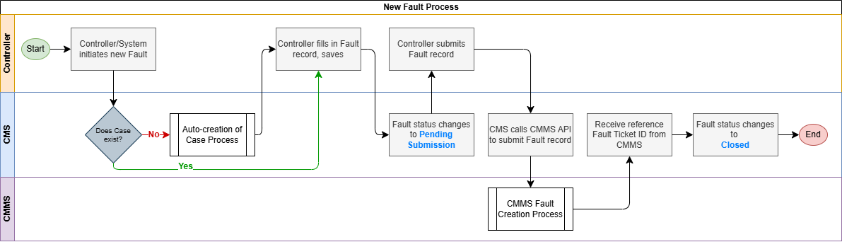
Figure 6-1 - CMMS Ticket Process

Fault Status and Information Retrieval

Fault Case Status
Status | Description | Actor
Pending Submission | Controller is filling up the fault record and is preparing to submit to CMMS | Controller
Closed | Automatically closed by CMS on receipt of the CMMS Fault ID. The Fault Ticket ID is stored on the Case for reference. The CMMS work order continues to be managed independently by IFM CMMS. | CMS

- Where fault status or details are required within the CMS, the system shall post a request to the CMMS API referencing the stored Fault ID to retrieve the relevant information.
- Retrieved fault data shall be surfaced on the associated Case record for operator reference.

Non-IFM Fault Handling
- Faults that fall outside current IFM CMMS scope, the interim arrangement is for these to continue to be recorded in the current system and not logged within the CMS.
Note: This arrangement will be revised once the IFM CMMS is expanded to cover non-IFM fault categories, at which point the CMS will route all fault submissions through the CMMS API.

Case Linkage and Closure
- The CMMS Fault ID shall be stored as a reference attribute on the CMS Case
- The CMS shall close the Fault record automatically upon receipt of the CMMS Fault ID, confirming successful submission to the CMMS
- The Fault record lifecycle is not dependent on the subsequent status of the CMMS ticket
- A Case may be closed after the CMMS ticket has been raised, without waiting for the CMMS ticket to be resolved.
- Multiple CMMS Fault IDs may be stored in a single Case where more than one fault is raised.

Task Management Module
Tasks are non-FM operational activities assigned to SDC staff for ground response or follow-up actions that do not constitute a formal FM work order.
- Tasks are created by Controllers and are always linked to a Case.
- A Task may exist within a Case independently of an Incident, or alongside an Incident where parallel ground activity is required.
- Tasks are distinct from the Responder Activity log within an Incident record, which captures actions taken by an assigned Ranger during the incident response.
- Tasks are distinct from CMMS tickets, which are FM work orders managed externally.

Task Creation
A Controller may create a Task at any point during the lifecycle of a Case. The system shall allow multiple Tasks to be created under the same Case.

Requirements
- Tasks are created by Controllers and higher roles (Duty Manager, Duty Officer, System Administrator) and are always linked to Case
- A Task is linked to a Case and is not required to be associated with an Incident.
Tasks may be created for any operational ground activity, including standalone requests such as item collection, escort, or access arrangements, as well as activities arising from or running in parallel with an active Incident.
- Tasks can be set as a recurring event and may be assigned to one Assignee or a group.
- For recurring Tasks, the recurrence schedule remains the template for creating future Task occurrences. Each generated Task is linked to its own Case and managed independently.

Task Field Design
The following fields shall be captured at the point of Task creation:
Field | Input Type | Mandatory | Notes
Task ID | System | Yes | System-generated upon Task creation. Not manually editable.
Linked Case ID | System | Yes | Auto populated from the Case the Task is created within.
Task Title | Text | Yes | Free text
Task Description | Text | No | Free text. Additional detail on the required action.
Assignee | Lookup | Yes | Selected from the CMS user directory. Any CMS-registered staff member may be assigned. See Section 3.
Priority | Dropdown | No | Normal, High; default to Normal
Due Date and Time | Date/Time | No | Optional target completion date and time
Checklist | Text | No | One or more items defined by Controller at creation or editing. All items must be ticked before the Assignee can mark the Task as complete.  When no checklist is defined, the Assignee may mark complete freely.
Recurrence Schedule | Date/Time | No | Set repeat creation of commonly scheduled tasks, and assigned to same Assignees or group of Assignees
Task Comments | Text | No | Comments section by Responder or Controller for the Task
Task Close Reason | Text | Conditional | For input by Controller. Mandatory if closing task before task is complete; non-mandatory if Task has been completed
Attachments | File upload | No | Supporting documents or images relevant to the Task
Created By | System | Yes | Auto-populated from the creating user's account.
Created Date and Time | System | Yes | Auto-populated at point of creation.

Task Assignment and Notification
- The system shall dispatch a notification to the assigned individual or all members of the assigned group upon Task assignment.
- Where a Task is subsequently reassigned, the Task status shall return to Assigned and the new assignee or assigned group shall receive a notification..
- Tasks may be assigned to an individual CMS user or a pre-configured group.
- Task assignment groups may be configured by the System Administrator, to allow for assignment of Tasks to a group of users.

Task Process

Requirements
- Status transitions per role are defined in the Roles and Permission Matrix, Section 3.4.2
- The Controller retains visibility of all Task statuses within the linked Case.
- The system shall not automatically close a Case while one or more linked Tasks remain open.
- Where open Tasks prevent automated Case closure, the system shall prompt the Controller to resolve of close or resolve outstanding Tasks.
- Once all linked Tasks and other linked sub-records meet their closure conditions, the system shall proceed with automated Case closure.
- A Task Close Reason is mandatory for any Task closed without Assignee completion.

Task Statuses
Each Task shall progress through the following statuses:
Status | Description | Permitted Actions
Created | Task has been created and not yet assigned to a Controller | Controller:  - Assign Assignee or group  - Edit task details  - Close tasks
Assigned | Controller has assigned a Responder or group to the Task | Assignee:  - Acknowledge  Controller:  - Assign / reassign  - Edit task details  - Close task
Acknowledged | Assignee has acknowledged receipt of the Task | Assignee:  - Start task  Controller:  - Assign / reassign  - Close task
In Progress | Responder has arrived on-site and commenced the Task | Assignee:  - Log task actions  - Mark task as complete/cannot complete  Controller:  - Assign / reassign  - Close task
Pending Further Action | Task is temporarily on hold pending further input or external dependency | Controller:  - Assign / reassign  - Close task
Closed | Task has been completed and closed | Controller:  - Reopen task

High-Level Task Process Flow
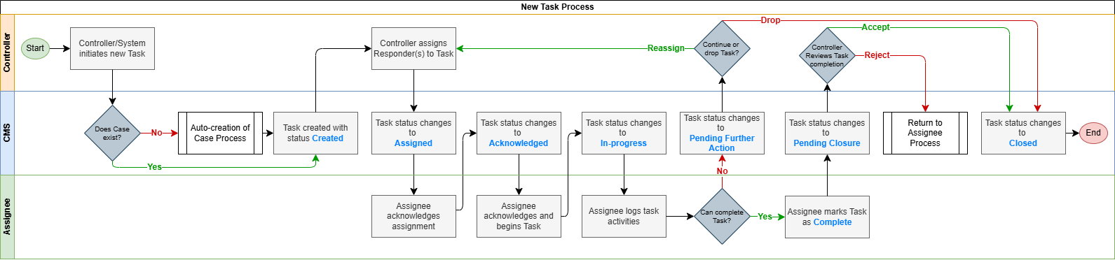
Figure 7-1 - Task Process

Events Master List Module
The Events Master List is a module for managing planned events on Sentosa Island. It provides Controllers with visibility of upcoming and active events alongside operational case records, supporting situational awareness and operational deconfliction

Events Creation

Requirements
- Authorised users shall be able to create, edit, and manage event records in the Events Master List.
- Authorised users shall be able to create an Event from an e-Diary entry where the e-Diary entry records event-related information
- The Events Master List shall retain references to source e-Diary entries where an Event is created from or later linked to an e-Diary entry
- Events are managed as Events Master List records and shall not affect Case status or automated Case closure.

Events Field Design
Field | Input Type | Mandatory | Notes
Event ID | System | Yes | System generated ID
Event Name | Text | Yes | Free text event name
Event Date and Time | Date/Time | Yes | Captures start and end date/time
Event Location | Location hierarchy lookup | Yes | Input location referencing location hierarchy, and boundary selectable on 2D Island Map
Event Type | Dropdown | Yes | Select from configured Event Type taxonomy
Description | Text | No | Free text event details
Linked e-Diary | System reference | No | Displays e-Diary entries from which the Event was created or later linked. Opens the e-Diary detail view.
Created By | System | Yes | Auto populated from user’s CMS account
Created At | System | Yes | Auto populated timestamp

Event Location
- Event location shall be selected from the location hierarchy
- The system shall not accept unrestricted unknown free-text values as the Event Location
- Where an Event covers a specific area, the authorised user may mark the Event area on the 2D island map within the selected location hierarchy area.
- The system shall prevent Event areas that fall outside the selected Location Hierarchy area or breach configured map-drawing rules.
- The System Administrator shall be able to maintain location hierarchy values, map reference points or boundaries, and map-drawing rules through System Configuration.

Events Schedule File Upload
- Authorised CMS users shall be able to upload an event schedule file for processing by the CMS
- Support file formats shall be confirmed during the technical design
- Event information, including name, date and time, location and details, shall be extracted and presented for user review and amendment.
- The CMS shall validate extracted Event Locations against the Location Hierarchy and flag missing, incorrect, non-matching or duplicate records for correction.
- The CMS shall not confirm an uploaded Event into the Events Master List until all flagged issues have been corrected.
- Confirmed Events shall be loaded into the Events Master List, with unsuccessful records reported to the user for review.

Event Calendar and List View
- The Events Master List shall provide a calendar view of all events, displaying upcoming and active events by date
- Events shall also be accessible as a list view with filtering by date range and event type

e-Diary Module
The e-Diary module is a module for recording events and interactions that fall under IOH responsibility but do not meet the threshold for a formal incident, fault, or task. The module digitises existing hardcopy occurrence logbooks currently maintained by the IOH Controllers, providing a searchable and filterable electronic record in place of the physical diary.
e-Diary records do not trigger a ground response, work order, or broadcast, and are not linked to the Case structure.
Common use cases include verbal interactions with members of the public, VIP and dignitary visit notifications, exercises, drills, and information dissemination activities.

E-Diary Creation
- The e-Diary module is primarily intended for use by Controllers. Duty Officers, Duty Managers, and System Administrators may also create e-Diary entries. All other CMS roles have no access to the e-Diary.
- Creation requires no approval or assignment workflow.
- e-Diary records can be edited even after submission but not deleted except by the System Administrator.

Requirements
- The e-Diary is a sub-record under the Case structure. Where no Case exists at the time of creation, the CMS shall auto-create a Case.
- Where an e-Diary entry escalates to require a formal response, a new Incident shall be created within the same Case. The e-Diary entry is retained as a journal record.
- Entries are mutable, a Controller may amend an entry after submission. All amendments are tracked and timestamped.
- File and image attachments are supported

e-Diary Field Design
Each e-Diary entry shall capture the following fields:
Field | Input Type | Mandatory | Notes
e-Diary ID | System | Yes | System-generated
Case ID | System | Yes | Auto-populated; auto-creates a Case if none exists
Linked Incidents | System Reference | No | Displays Incidents created from or linked to the e-Diary entry. Opens the Incident detail view.
Linked Tasks | System Reference | No | Displays Tasks created from or linked to the e-Diary entry. Opens the Task detail view
Linked Events | System Reference | No | Displays Events created from or linked to the e-Diary entry. Opens the Event detail view
Create or Link Record | Action | No | Allows an authorised user to create or link an Incident, Task or Event from the e-Diary entry
Created By | System | Yes | Account holder creating the entry. System-populated from authenticated session
Date / Time | Date/Time | Yes | Defaulted to current date and time. Backdating permitted
Topic | Text | No | Structured or free text
Entry Text | Text | No | Free text narrative
Attachments | File upload | No | File / image references

Create or Link Records from e-Diary
- An authorised user may create or link an Incident, Task or Event from an e-Diary entry where the diary entry requires follow-up action, formal incident management or event registration.
- Where an Incident or Task is created from an e-Diary entry, the new record shall be created within the same Case as the e-Diary entry and shall retain a reference to the source e-Diary entry.
- Where an Event is created from an e-Diary entry, the Event shall be created in the Events Master List and shall retain a reference to the source e-Diary entry.
- Events are not Case sub-records and shall not affect Case status or automated Case closure
- The e-Diary entry shall remain unchanged as the source journal record after an Incident, Task or Event is created or linked

Retrieval and Filtering
- The system shall support retrieval of e-Diary records with filtering by date and by user account.
- Additional filtering criteria may be introduced subject to the confirmed field list from SDC.

UCS Integration
- The e-Diary shall be accessible as a module within the UCS, allowing Controllers and Duty Officers to create and retrieve occurrence entries without navigating to the CMS.
- The UCS surface requirements for the e-Diary are defined within the UCS Functional Requirements Document.

Broadcast and Notification Framework
The Broadcast and Notification Framework govern the composition, delivery, and record-keeping of all outbound communications generated by the CMS. Broadcasts are structured communications issued to defined recipient groups in response to incident lifecycle events.
Notifications are system-generated alerts directed to individual users in response to record assignments, status changes, or workflow actions.

Broadcast Types
Broadcast Type | Trigger | Initiator
Closure Broadcast | Duty Manager approves incident closure; system notifies Controller to perform Closure Broadcast | Controller, upon accepting system notification. Broadcast composition menu is presented for Controller to confirm fields and recipients before dispatch
End-of-Day Interim Broadcast | End of operational day, system notification prompts Duty Manager to review open incidents and confirm whether a broadcast is required | Duty Manager  Not all open incident require a broadcast, the Duty Manager decide per incident
Weather Advisory Broadcast | Weather forecast or weather alert information surfaces on the UCS | Authorised User, upon reviewing the weather alert and confirming the broadcast content and recipients
- All broadcasts are delivered via email to configured distribution groups. Informational and/or Exercise Records do not trigger closure broadcast prompts, interim broadcast queues or crisis broadcast routing by default.
- An authorised user may separately initiate a Broadcast where a confirmed operational need exists.

Delivery Channels
Channel | Used For | Notes
Email | Closure broadcasts; end-of-day interim broadcasts | Directed to configured distribution groups
Push Notification | System notifications and operational prompts | Delivery channel subject to supported user interfaces, CMS, UCS, and/or Staff App interfaces

Recipient Group
- Distribution groups shall be managed as named collections of user email addresses, configurable by the System Administrator.
- The system shall support creation, editing, and deactivation of distribution groups.
- On broadcast initiation, the system shall pre-populate the recipient field with the default distribution group mapped to the incident type and crisis level.
- The Duty Manager or Controller may add or remove individual recipients prior to dispatch without modifying the group configuration permanently.

Broadcast Templates
- The system shall support configurable broadcast templates mapped to incident type and crisis level.
- Templates shall define the default set of incident fields included in the broadcast.
- Default templates shall be configured to exclude sensitive content, defined as details that are operationally sensitive, under active investigation, or unsafe for wider distribution.
- Inclusion of fields beyond the default requires explicit confirmation by the Duty Manager at the point of dispatch.
- Templates shall be configurable by the System Administrator
Note: Broadcast template content per incident type and crisis level to be confirmed.

System Notifications
The system shall generate automated notifications to individual users for the following events:
Event | Recipient
Task assigned or reassigned | Assignee
Incident assigned for Responder Activity | Responder
Responder incident log submission: review prompt | Controller
Incident log returned for revision by Duty Manager | Controller of incident
NOP status change | Applicant and relevant approvers
CMMS Fault ID received | Controller of linked Case
Incident active for 12 days: advance ageing alert | Duty Team*
Incident active for 14 days: ageing alert action required | Duty Team*
Incident closed: closure broadcast prompt | Controller of closed incident
Note: Duty Team refers to the Duty Manager, Duty Officer and Controllers on shift.

Broadcast Matrix
[TBC – Full broadcast matrix]

End-of-Day Interim Broadcast
- At the end of each operational day, the system shall surface a queue of open incidents flagged for interim broadcast to the Duty Manager.
- Not all open incidents require an interim broadcast. The Duty Manager shall review each incident in the queue and decide whether a broadcast is required.
- For each incident in the queue, the Duty Manager shall select the applicable template, confirm the content to be included, and approve dispatch.
Note: Broadcast timing rules and criteria governing which active incidents are surfaced in the interim broadcast queue are to be determined.

SDC Communications Team Notification
- When media is confirmed at an Incident scene, a prompt is surfaced to the Duty Manager on the UCS.
- The Duty Manager assigns a Controller to inform the SDC Communications team.
- The assigned Controller records confirmation once the notification has been made.

Broadcast Record and Export
- All dispatched broadcasts shall be logged against the originating Case record and identified by Broadcast ID.
- Each Broadcast record includes the recipient list, template used, content dispatched, date and time of dispatch, sending Controller and dispatch status.
- The originating Incident record shows whether a Broadcast has been sent, and the latest Broadcast status.
- Where delivery status is available from the delivery channel, the Broadcast record shows delivery counts by status, including sent, delivered, failed and pending
- Where recipient acknowledgement is required and supported, acknowledgement counts are also shown.

Crisis Management and Emergency Recall
Crisis Recall is distinct from the broadcasts described in the previous section. While Broadcasts disseminate incident information to external recipients via email. Crisis Recall is the activation of named stakeholder groups to the command centre, triggered by an incident classified at Level 4+ or above, and delivered via selected communication medium.

Crisis Level Classification and Routing
Each incident shall be assigned a crisis level from 1 to 5 that determines the broadcast type, delivery channel, and recipient group as follows:
Crisis Level | Description | Broadcast Behaviour | Crisis Recall Behaviour
Level 1–3 | High-severity incidents | Fixed broadcast via emails | Select recall via SMS with acknowledgement to defined distribution groups
Level 4+ | Incidents requiring SCOG activation | Fixed broadcast via email | Select recall via SMS with acknowledgement to defined distribution groups
Level 4 | Routing incidents | Targeted email broadcast to relevant distribution groups
Level 5 | Occurrences and false alarms | Targeted email broadcast to relevant distribution groups
- Level 1 is the most severe; Level 5 is the least severe (occurrence or false alarm).
- Crisis level may be influenced by dynamic factors including media or press presence, reputational impact, and number of persons involved.

Crisis Recall
- Crisis Recall shall be triggered when an incident is classified at Level 4+ or above.
- Crisis Recall is semi-automated. An authorised user (Duty Manager) must reivew and confirm the recall before dispatch
- At Level 4+, the specific relevant stakeholder group shall be recalled. At Level 3 and below, a broader set of SDC stakeholders shall be recalled.

Delivery Channels
Channel | Used For | Notes
SMS | Crisis recall at Level 4+ and above | Includes recipient acknowledgement feature; routed via selected communication medium

SMS Recall Workflow
- For incidents at Level 4+ and above, the system shall generate and queue a crisis recall SMS based on the incident classification and configured recipient group.
- An authorised user (Duty Manager) shall review and confirm the queued message before dispatch.
- The system shall surface SMS acknowledgement status to the authorised user (Duty Manager) upon receipt by recipients.

Recall Groups
- Recall groups are named collections of recipients used for Crisis Recall dispatch
- The System Administrator can create, edit and deactivate Recall Groups
- Each Recall Group includes the group name, description, members, contact details, membership status and applicable crisis recall routing rules
- Recall Groups have similar group-management features as Broadcast distribution groups but are separate from them.
- During crisis operations, an OR Analyst assigned to recall group operations can manage the operational recall group and its members for the active crisis, including adding, removing or updating members as required for crisis response.

Reporting and Data Export
The Reporting and Data Export module provides structured exports of CMS records for operational record-keeping, management review, and downstream analytics.
Export outputs are distinct from broadcast content. Fields included in an export may differ from those included in a broadcast for the same incident.

Operational Statistics Module
The Operational Statistics module is a dedicated analytics surface accessible from the main CMS navigation. It provides in-built visualisations and data export across all core operational record types.
- The module shall provide in-built analytics across Cases, Incidents, Faults, Tasks, e-Diary entries, Events and No-Objection Permits, including the following:
Chart / Metric | Description Example
Volume Trends | Daily count of records over selected period
Status Breakdown | Distribution of records by current status
Type Breakdown | Distribution of incidents by type and sub-type
Location Breakdown | Distribution of incident by location
Processing time metrics | Daily average pending time and processing time
- The module shall support user-selectable date range filtering, with preset shortcuts for the last 7 days, 30 days, last 12 months, and a custom range.
- Data export shall be available directly from any chart or table view, in PDF format for period summaries and CSV format for bulk record export
- Access to the Operational Statistics modules and export of reports shall be governed by the user's assigned role
- Operational Resilience Analysts access shall extend to live and closed records across all record types to support post-incident classification, tagging and trend analysis.

Incident Report Export
- The system shall support export of a formal incident report for each closed incident.
- The report shall present a structured summary of the incident record fields and shall be exportable in PDF format.
- The fields included in the incident report export shall be defined separately from the incident form field structure, as the export may present a subset or differently formatted representation of the full record.

Case Summary Export
- The system shall support export of a case summary record presenting the key attributes of a Case, including and not limited to:
- Linked incident reference and status
- Task count and status summary
- CMMS Fault ID references
- Case status history and closure timestamp
- e-Diary
- Export shall be available from any chart or table view, in PDF format for the summaries and CSV format for bulk record export.

Data Export for Analytics
- The system shall support bulk data export of incident and case records and their sub-records, including incidents, faults, tasks, and e-Diary entries, in CSV format to enable downstream analytics by authorised parties.
- The bulk exported shall support filtering by, and not limited to:
- Date Range
- Incident Status
- Incident Type and Category
- Crisis Level
- Location
- Access to report and data export functions shall be governed by the user's assigned role.

System Configuration and Administration
The System Configuration and Administration module provides System Admins with the tools to manage users, roles, reference data, and broadcast configuration across the CMS.

User and Role Management
- The System Administrator shall be able to create, edit, deactivate, and reactivate user accounts.
- Role assignment shall follow the role structure defined in Section 3
- The default access model shall be role-based group assignment, with individual access exceptions handled on a per-request basis by the System Administrator.
- Where users are authenticated via WOG SSO, account provisioning may be partially automated based on Active Directory attributes such as department or organisational unit.
- Accounts requiring permissions beyond the default role assigned by domain authentication shall require manual role assignment by the System Administrator.

System Reference Data Configuration
The System Administrator and the Current Ops Administrator shall be able to configure the following reference data sets without developer intervention:
Configuration Item | Notes | System Administrator | Current Ops Administrator
Incident Type and Sub-type taxonomy | Mandatory fields at incident creation | Configure | Configure
Fault Type and Sub-type taxonomy | Governs CMMS ticket creation and severity rules | Configure | Configure
Location hierarchy | Configurable Road, Building, Level and Space values used for structured location selection, map plotting, filtering and reporting | Configure | Configure
Task priority levels | Configurable labels and definitions | Configure | Configure
e-Diary Type and Sub-type taxonomy | Mandatory fields at e-Diary creation | Configure | Configure
Auto-save interval | Frequency of automatic record saving during active editing | Configure | View-only
Record lock timeout | Duration before an inactive editing session lock is released | Configure | View-only
Task checklist templates | Create, edit and deactivate reusable checklist templates for Task creation | Configure | Configure
Action prompt rules | Configure trigger conditions, recipient roles and prompt text for system action prompts, e.g. Incident Ageing, SDC Communications team notification prompts | Configure | View-only

Broadcast Configuration
Configuration Item | Notes | System Administrator | Current Ops Administrator
Broadcast Distribution groups | Create, edit, deactivate named recipient groups for delivery broadcast | Configure | Configure
Broadcast routing matrix | Map incident type, sub-type and crisis level to broadcast distribution groups and delivery channels | Configure | Configure
Broadcast templates | Define and edit default field sets per incident type, sub-type and crisis level | Configure | Configure
End-of-day broadcast timing | Define the time at which open Incidents are surfaced in the Duty Manager's end-of-day interim broadcast queue | Configure | Configure
Broadcast action prompt rules | Configure trigger conditions, recipient roles for broadcast related prompts | Configure | Configure

Recall Configuration
Configuration Item | Notes | System Administrator | Current Ops Administrator
Recall groups and members | Create, edit and deactivate recall groups, maintain members, contact details and membership status | Configure | Configure
Recall routing rules | Map crisis level or incident classification to the default recall group | Configure | Configure
Recall message templates | Define default recall message content by crisis level, incident type or recall group | Configure | Configure
Recall messaging services settings | Connection parameters for the on-premises SMS gateway | Configure | View-only
Recall acknowledgement and escalation rules | Configure acknowledgement requirements where applicable, reminder rules, escalation rules and related audit events | Configure | Configure

Audit Log
- All user actions, configuration changes, and system events shall be captured in the system audit log automatically.
- The audit log shall be accessible to the System Admin and Current Operations Administrator only.
- The audit log shall support filtering by user, action type, date, and record reference.
- Audit log records shall be immutable and retained in accordance with the data retention policy.

Non-Functional Requirements

Availability

Performance

Concurrent Users

Security

Session Management

Audit and Compliance

Data Retentional and Archival

Open Items

UCS
Note: The full list of CMS widgets/items to be made available as embedded widgets on the UCS dashboard is still under discussion with SDC.

Incident
Note: Finalised Incident Type and Sub-type taxonomy to be confirmed

Broadcast
Note: Broadcast template content per incident type and crisis level to be confirmed.
Note: Broadcast timing rules and criteria governing which active incidents are surfaced in the interim broadcast queue are to be determined.
Broadcast Matrix

Central Rostering Module
- Central Rostering is a proposed CMS module for managing duty rosters for IOH staff, Rangers, contractors and designated on-duty personnel.
- Similar to the Events Master List, the module would maintain structured roster records and expose relevant current-duty information to operational views.
- UCS may surface the assigned response team, Duty Manager and other designated on-duty personnel for situational awareness.
- Scope, ownership, roster data input method, user groups, source of truth and integration with CMS notifications remain to be confirmed.

Appendix

